1 .Open Bus Hound

Note—USB Short Circuit unplug

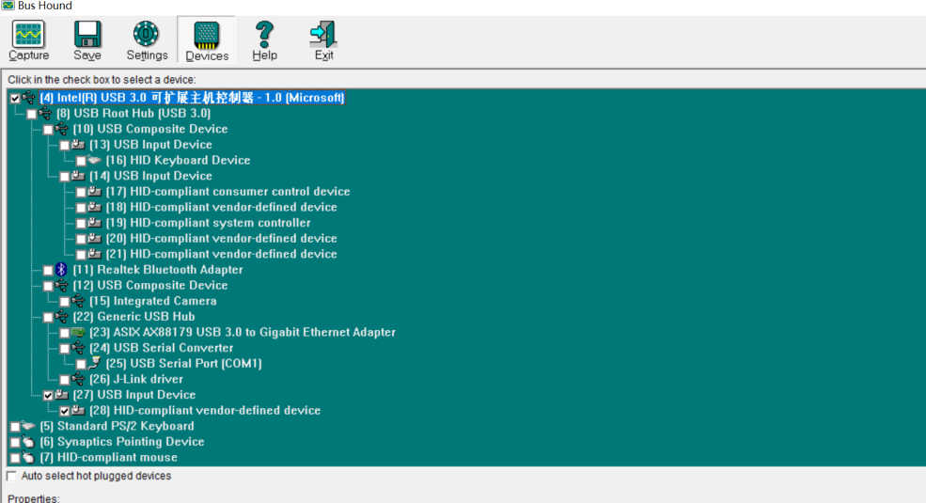

2．Double--Click USB Input Device

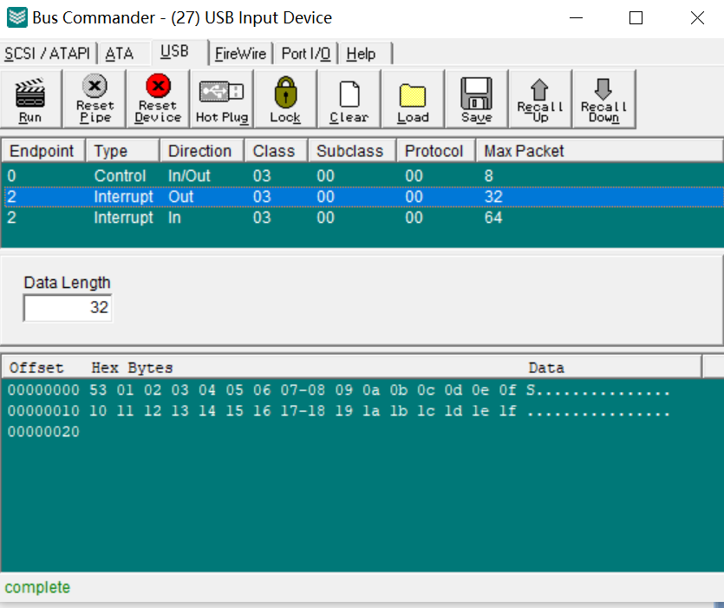

3.Click --Interrupt out

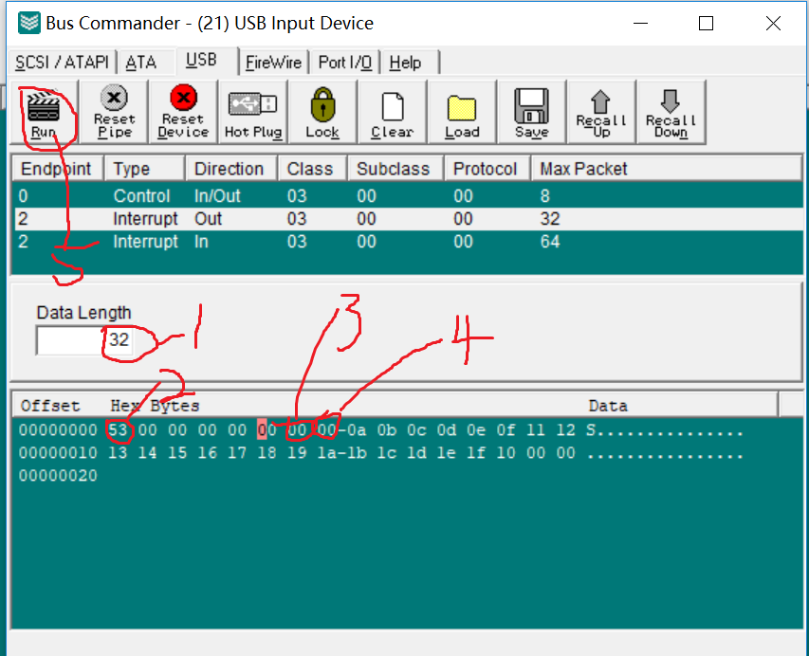

(1)----Data Length—write32

(2)--- Head Code-- 0x53

(3)--- Walking machine LED status

(4)---PWM（0x00—0x65）--the higher the value, the greater the resistance

(5)---Run

4.Click Capture -----Red is Speed

